Bog-standard genius: Banksy's rats show great artists shine in solitude
The street artist has kept busy by painting his toilet. But as everyone from Giorgione to Van Gogh can attest, separation from society can do wonders for the creative mind
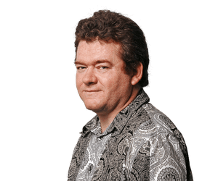
Jonathan Jones
Thu 16 Apr 2020 16.39 BSTLast modified on Thu 16 Apr 2020 17.23 BST

Shares
392

Comments
230
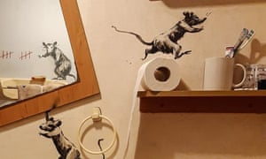
Bathroom-sink realism ... Banksy’s redecorated restroom. Photograph: Banksy/PA
What’s a street artist to do when the streets are locked down? Banksy’s got nothing to keep him busy except create mayhem in his own bathroom. He has released photographs of what he says is his loo decorated with stencilled rats in a trompe l’oeil rodent rampage – swinging from the towel holder, balancing on a mirror frame, perching on a toilet splashed with orangey-brown matter.
For these filthy beasts long associated with plague, coronavirus means party time. They are celebrating our decline and fall. Maybe Banksy sees the anarchic potential in a world that has decided to suspend normal business.
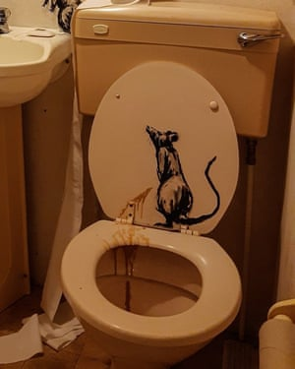
Photograph: Banksy/PA
Is there something about being isolated that releases the best in artists? David Hockney shares paintings of resurgent nature, Tracey Emin confesses her fears and now Banksy reveals the surreal side of spending too much time at home. Isolationism – to pin a label on these various responses to a shared crisis – is a new kind of art because this is a new kind of crisis. But artists have been isolated before, and what they produced confirms that being separated from society can do wonders for the creative mind.
Artists were quarantined for illness as early as the Renaissance, when Italian cities pioneered social distancing measures as they struggled with plague. The Venetian painter Giorgione died on the lagoon city’s quarantine island Lazaretto Nuovo in 1510. According to his biographer Vasari, he chose to isolate alongside his infected lover and caught the fatal illness. On this island of socially excluded dying people, he may have created his most famous masterpiece, the Sleeping Venus. As Giorgione and his lover lay sick and isolated, he made this one last painting of her. She’s not just sleeping – she’s dying or dead. And as she lies there he records his love. (He doesn’t show the buboes, of course.)
The illnesses that have usually led to the isolation of great artists, however, are mental rather than physical. Richard Dadd spent most of his adult life in the closed hospitals of Bedlam and Broadmoor after he murdered his father, who he believed was the devil. Dadd’s doctors encouraged his art even though he never recovered. He painted strange, intense portraits of his carers as well as fantastically detailed scenes of fairy life. Freedom was an escape into microscopically precise visions of tiny demonic beings. Thinking about his painting The Fairy-Feller’s Master-Stroke, I’m starting to worry about Banksy. His rampaging rats are not so different from these deliriously anarchic Victorian fairies.

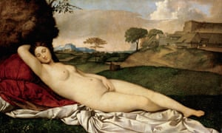

FacebookTwitterPinterest
Dying creation ... Giorgione’s Sleeping Venus. Photograph: Archivart/Alamy Stock Photo
Vincent van Gogh accepted that he needed to be confined after he cut off his earlobe and was hounded as a “madman” by the people of Arles. He was locked up for a year in the Saint-Paul Asylum at Saint-Remy. While there, he positively thrived as an artist. He fixed his eyes on the asylum garden, its yellow corridors, its lonely patients. It was while looking out of his window in the asylum that he painted his ecstatic vision of cosmic glory The Starry Night. Vincent killed himself three months after leaving the asylum. He might have been better off staying there.
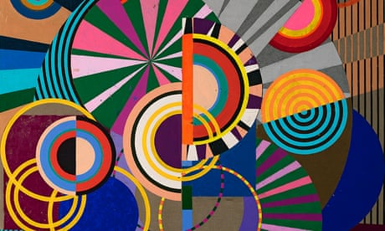

Sign up to the Art Weekly email

Read more
Van Gogh helped inspire the 20th-century cult of “outsider art” or art Brut, which sought out and recognised the works made by asylum patients. Jean Dubuffet, apostle of art brut, promoted the work of Swiss asylum patient Aloïse Corbaz. Her swirling orange and blue fantasies have some of the electricity of The Starry Night.
Other artists have chosen to self-isolate of their own free will. The great abstract painter Agnes Martin got so sick of the noise of the New York art world that she fled in 1967 to a life of solitude, living in a series of adobe dwellings she built for herself in the New Mexico desert. Her absorbing networks of ethereal marks in fields of whiteness are monuments to the peace and silence she found in her wilderness retreat. In a way she was imitating earlier women artists who lived in confinement as nuns. The Renaissance artist Plautilla Nelli spent her life in a convent in Siena but won widespread recognition.

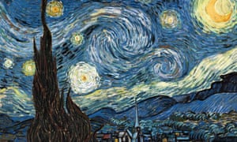

FacebookTwitterPinterest
Ecstatic vision ... Vincent van Gogh’s Starry Night. Photograph: Alamy Stock Photo
Art itself is torn between the social and the isolated. It is all about communicating with others, yet the best art is introspective. Even Banksy, whose art is nothing if not social, has been driven to his own kind of introspection: Rats! Rats! I can see rats! Then again, he chooses to be anonymous so perhaps he’s a shy person at heart.
There’s something tragicomic about trying to see the bright side of coronavirus. Isolation does, however, seem to be releasing modern art’s inner hermit. Far from the madding crowds of fairs and biennials, artists are rediscovering the solitary springs of creativity.

